12.27: a) Eliminating the orbit radius r between Equations (12.12) and (12.14) gives

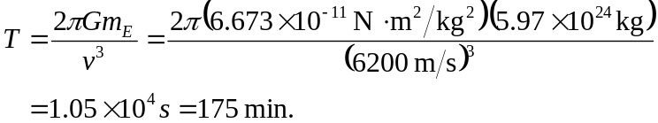

b) 